PROFESSIONALISATION OF YOUTH WORKERS

Key Points
- Information About Professional Youth Work
- Youth worker – an easy job?
- Importance of Non-formal Learning for Professional Youth Work
- 5 Basic Values for the Professionalisation of Youth Work
Introduction
The professionalisation of youth workers around the world is a growing trend. When youth work began in the world, youth workers were only doing it voluntarily. Youth work is a great benefit not only to young people but also to society. Youth workers who make a great contribution to society and play a major role in the recruitment of young people should perform this work in a professional manner. Therefore, youth workers started to perform this job as a profession in time. This article mainly focuses on what professional youth work is, whether it differs from country to country, how youth workers educate young people and their impact on young people, and the core values of professionalisation in youth work.
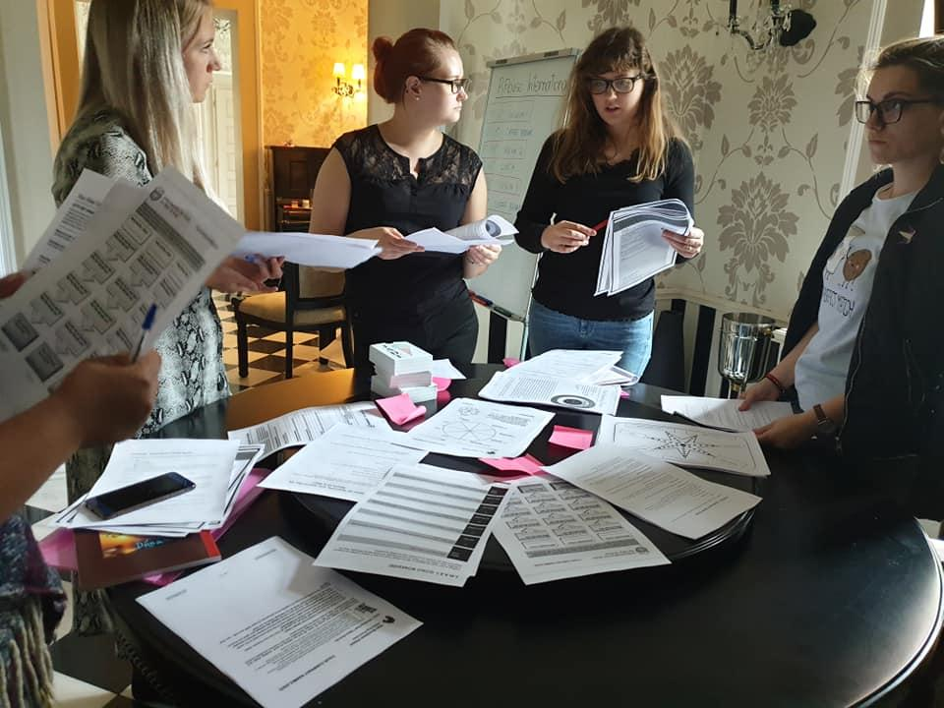
Briefly About Professional Youth Work
In this article we will inform you about the professionalisation of youth workers. First of all, we want you to know what professional youth work is. Professional youth work is carried out by paid workers who demonstrably master relevant knowledge, skills and attitudes obtained through a combination of formal education, peer-learning and experience in working with young people. In most countries there is no homogenous training system for youth workers (Declaration 1st european youth work convention, 2010; Dunne et al., 2014).
“Professionalisation” has a dynamic feature. It refers to a process of change over time, to develop and change important aspects of a profession. Youth work practices vary from country to country. In some countries there is a professional part of youth work. In these countries, youth work is included in the education and social welfare system. In other countries, youth work is not linked to these systems. Volunteers in these countries carry out youth work. In addition, some countries carry out youth work in two ways.
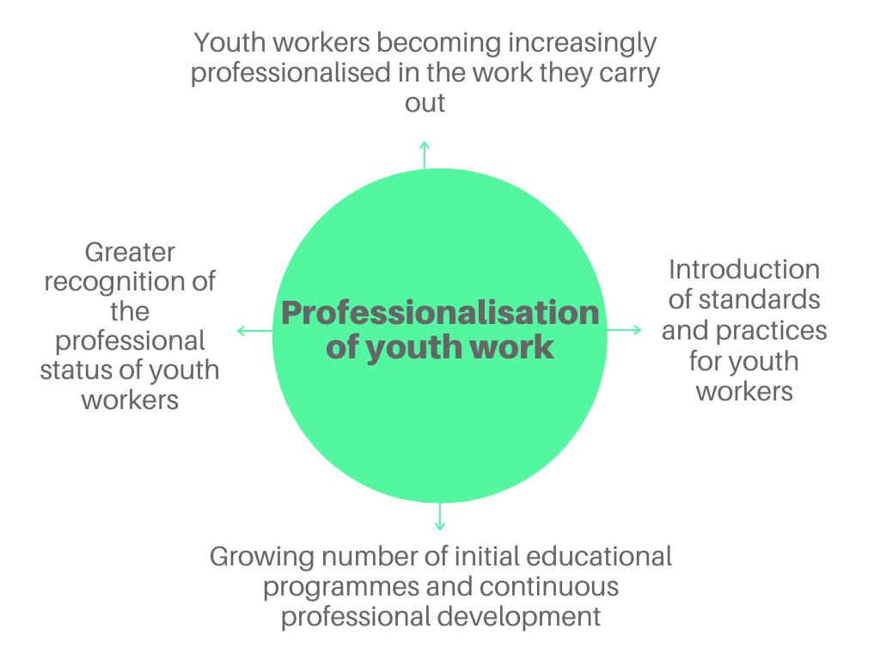
Figure 1: Professionalisation of youth work. (Adapted from European Comission, 2014)
Training and courses for youth work have been established in universities or other higher education institutions. The exact location of the course programs shows the stage at which youth work reaches the professionalisation process. As we see also in figure 1 growing number of initial educational programmes and continuous professional development is one indicator to guarantee the professionalisation of youth work. According to the figure 1 other significant factors for professionalism in youth work are youth workers professional approach to the work, their awareness of general knowledge and practices in youth work. An important feature is also recognising youth workers status as a professional.
Appreciation for youth work as an actual profession with professional workers has been increasing but instability of working conditions, lack of recognition and support and increasing pressure on the sector is still causing difficulties for youth workers and their work with youth . Professional youth worker can be formally trained or might have been through training or development which has been provided by, for example, youth organisation, the Government or initiatives themselves. The European Commission has noticed the need of supporting youth workers and has already made some actions to strengthen their profile and competence and also recognition of their experience, professionalism and contribution to the field of youth work.

Youth worker – an easy job?

Some people nowadays still assume that youth workers “just hang around and have fun with the youth”. Admittedly, this is what it may look like for an outsider. But when you take a closer look on the matter, you realise it is more than that. While spending time with the youngsters, the youth workers are actually addressing the needs and aspirations of young people, providing learning opportunities, supporting and empowering young people in making sense of the society they live in and in engaging with it, supporting young people in actively and constructively addressing intercultural relations, supporting collective learning in teams, just to name few. Many people choose a job in the youth work sector because they mistakenly think that it is an easy profession that you can practise without putting in much effort. However, we can conclude that serious and professional youth work is not something that everybody can do. That is why certain standards for the professionalisation of youth workers have to be created. Otherwise, there will be increasingly more youth workers with an attitude to work similar to the one in the picture on the right.

Importance of Non-formal Learning for Professional Youth Work
At school, youths experience formal education. This is what you could consider the old-fashioned way of teaching. The teacher has a very clear plan of what he wants the students to know by the time they leave the classroom. The important thing is the result of the learning, not the process of learning itself. On the other hand, a hallmark of professional youth work is the non-formal learning. That means that there is not one authority, in our case the youth worker, who is supposed to just impart their knowledge while the recipients of the information just “soak it up”. No, the aim of non-formal learning is to allow to the youngsters to learn something new while solving a certain task without any clear instructions of the responsible youth worker. This method of learning focuses more on basic capabilities like being able to cope with unforeseen obstacles and working together as a team rather than simply implementing instructions to achieve a given goal in the best and fastest way. And at this point, we can come back to question why professionalisation is so important. Most people do not have the inherent ability to provide non-formal learning. When they see young people struggling with a task, they will just offer their help by showing them the best way to do it. A professional youth worker however has learned not to just tell the solution but to give hints that will lead the youngsters on the right way in order for them to learn from their mistake and get on the right direction by themselves. This is perhaps the most important reason why there must be certain standards regarding the professionalisation of youth workers.
5 Basic Values for the Professionalisation of Youth Work
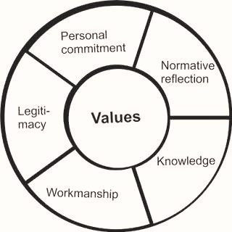
Figure 2: Professionalism of professional youth work (Metz, 2017)
According to Figure 2, there are 5 different values to professionalization of youth work. These are the basis for the professionalisation of youth work and ensure good quality. The first value is personal commitment. Because personal commitment to youth is the starting point in youth work. Moral consciousness and capacity of judgement is one of the values necessary to practice the profession with young people. Normative reflection refers to this value. Knowledge and workmanship is essential for every professional work. What is important in youth work is provide information in non-formal way. As in any profession, legitimacy is important in professional youth work to provide accountability.
Youth is a huge resource for society and it’s important that we can lead that resource to the right direction and meet goals that benefit also the society. This can be done by professional youth work. Youth work focuses on youth, their participation and personal development in order for them to deliver their full potential. For youth, it is always voluntary to participate. Youth work can be organized for example by organisations, youth services and public authorities and its range of activities is diverse. It’s important to keep in mind that youth work includes all youth from different backgrounds whether they succeed in school or not. Often youth that won’t shine in formal education or perhaps has been dropped out from school, they’ll find their strengths and interests with help of professional youth worker.
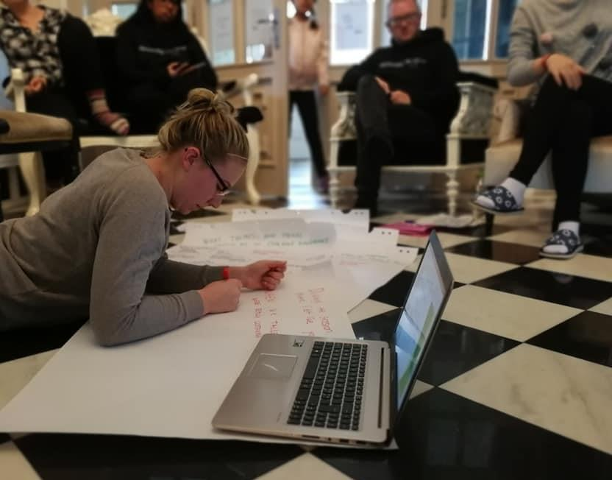

Conclusion

Let´s bring together the different key points covered in the article. Youth work is a professional field just like any other job out there. If you hire an architect to build your house, you want one who is an expert in his profession, someone in whose capabilities you can trust. You do not want your house to be an insecure and energy-inefficient disaster.
The same principle also applies for youth work. The youngsters of today are the rulers of tomorrow. It is our responsibility and our duty to prepare these youngsters in the best way possible for what is coming at them in the future. This important task should under no circumstances be left to amateurs who have no psychological or educational expertise and have never learned how to handle youth with all their complicated problems. Professionalisation of youth workers is essential in order to build a good base for a well-working and secure future society.

References
Council of Europe. European youth work convention 2015. Overview of recent developments at European level with regard to youth work.
Declaration 1st European Youth Work Convention, ghent, belgium, 7-10 juli 2010.
Dunne, A., Ulicna, D., Murphy, I., & Golubeva, M. (2014). 2. what is youth work? In A. Dunne, D. Ulicna, I. Murphy & M. Golubeva (Eds.), Working with young people: The value of youth work in the european union (pp. 53-87). Brussels: IFC GHK.
European Comission (2020). https://ec.europa.eu/youth/policy/implementation/work_en
European Comission (2014). Working with young people: the value of youth work in European Union
Metz, J. W. (2017). The professionalism of professional youth work and the role of values
History of youth work. (2014). Retrieved January 10, 2020, from youth partnership website: https://pjp-eu.coe.int/en/web/youth-partnership/history-of-youth-work

The history of youth work in Europe. (n.d.). Retrieved from https://pjp-eu.coe.int/documents/42128013/47261623/TheHistoryOfYouthWorkVol3.pdf/57009717-9c65-45c7-9714-df202038d607

